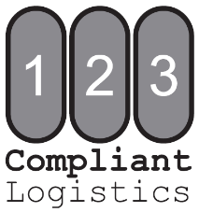

Instructions

- Complete Customer Information as indicated on DEA Controlled Substances Registration Certificate
- Complete all fields for Schedule I-II inventory being sent for destruction
  - Partials must be listed on separate lines (please see example below)
- Sign and date completed form

Do NOT ship Schedule I-II items at this time

- Fax or Email completed Schedule I-II Inventory Form:
123 Compliant Logistics
123 FAX: (480) 659-2353
123 Email: info@123compliant.com

**Upon receipt of Schedule I-II Inventory - Request for DEA Form 222, 123 Compliant Logistics will prepare official DEA Form 222 and mail to the DEA Registered Address

- Once you receive the DEA Form 222, confirm the information is correct and enter the Quantity Shipped and Date Shipped (instructions with example will be included in your envelope)
  - Keep the Original Copy of your DEA Form 222 for your records
  - Mail a Photo Copy of your DEA Form 222 to your local DEA office
    - Addresses can be found here
  - Include a Photo Copy of your DEA Form 222 in your destruction shipment

- Once you receive authorization to ship, pack and mail your shipment
  - Enclose photo copies of the DEA Form 222 and Schedule I-II Inventory Form
    - Flat Rate Box Customers - Call or email to request a shipping label
    - Bulk Customers – Use shipper of your choice
      - We require using a shipping method that can track and confirm delivery of your shipment
Example
Orig. Pkg. Size | Count in Pkg. | Qty. of Pkgs. | Description (include dosage form) | Strength | NDC
100 tab | 100 tab | 12 | Dilaudid Tablets | 2mg | 00074-2415-14
100 tab | 62 tab | 1 | Dilaudid Tablets | 2mg | 00074-2415-14
20ml | 20ml | 8 | Fentanyl Injectable Solution | 50mcg/ml | 00409-9094-16
20ml | 7.2ml | 1 | Fentanyl Injectable Solution | 50mcg/ml | 00409-9094-16
20ml | 5ml | 1 | Fentanyl Injectable Solution | 50mcg/ml | 00409-9094-16

Customer Information
Facility Name |  |  |  |  |  |  |  | Date
DEA Registrant Name
Registered Address
City |  |  |  |  |  | State |  |  | Zip
Facility Contact |  |  |  |  |  |  | Phone
Email |  |  |  |  |  |  | Fax
DEA # |  |  | DEA Expiration Date |  | State License #

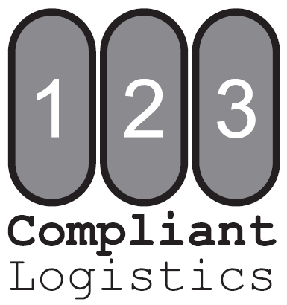
Orig. Pkg. Size | Count in Pkg. | Qty. of Pkgs. | Description (include dosage form) | Strength | NDC

 | Signature (person completing this form) |  | Title |  | Date

