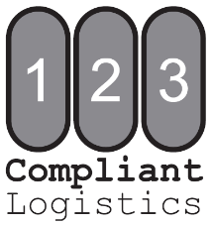

Instructions

- Complete Customer Information as indicated on DEA Controlled Substances Registration Certificate or Professional State License
- Complete all fields for Non-Scheduled inventory being sent for destruction
  - Partials must be listed on separate lines (please see example below)
- Sign and date completed form

Do NOT ship Non-Scheduled items at this time

- Fax or Email completed Non-Scheduled Inventory Form:
123 Compliant Logistics
123 FAX: (480) 659-2353
123 Email: info@123compliant.com

**Upon receipt of Non-Scheduled Inventory Form, 123 Compliant Logistics will review all information and grant shipping authorization via email or phone.

- Once you receive authorization to ship, pack and mail your shipment
  - Enclose photo copies of the Non-Scheduled Inventory Form
    - Flat Rate Box Customers - Call or email to request a shipping label
    - Bulk Customers – Use shipper of your choice
      - We require using a shipping method that can track and confirm delivery of your shipment

Schedule II, III-V and Non-Scheduled pharmaceuticals may be shipped in the same box
If further clarification is needed, please call (602) 612-4140

Example
Orig. Pkg. Size | Count in Pkg. | Qty. of Pkgs. | Description (include dosage form) | Strength | NDC
30 tab | 30 tab | 8 | Azithromycin Tablets | 600mg | 51224-0222-30
30 tab | 15 tab | 1 | Azithromycin Tablets | 600mg | 51224-0222-30
25x1ml | 25x1ml | 5 | Promethazine Injection Ampules | 25mg/ml | 00591-3157-83
25x1ml | 21x1ml | 1 | Promethazine Injection Ampules | 25mg/ml | 00591-3157-83
1ml | 0.8ml | 1 | Promethazine Injection Ampules | 25mg/ml | 00591-3157-54

Customer Information
Facility Name |  |  |  |  |  |  |  | Date
DEA Registrant Name
Registered Address
City |  |  |  |  |  | State |  |  | Zip
Facility Contact |  |  |  |  |  |  | Phone
Email |  |  |  |  |  |  | Fax
DEA # |  |  | DEA Expiration Date |  | State License #

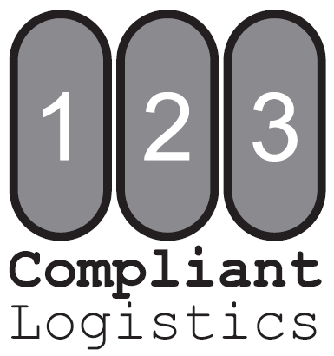
Orig. Pkg. Size | Count in Pkg. | Qty. of Pkgs. | Description (include dosage form) | Strength | NDC

 | Signature (person completing this form) |  | Title |  | Date

